At top end

Throw in value prop by

1)Create a context object

2)Show ___Context.Provider

Give it a value prop of whatever information we want to share

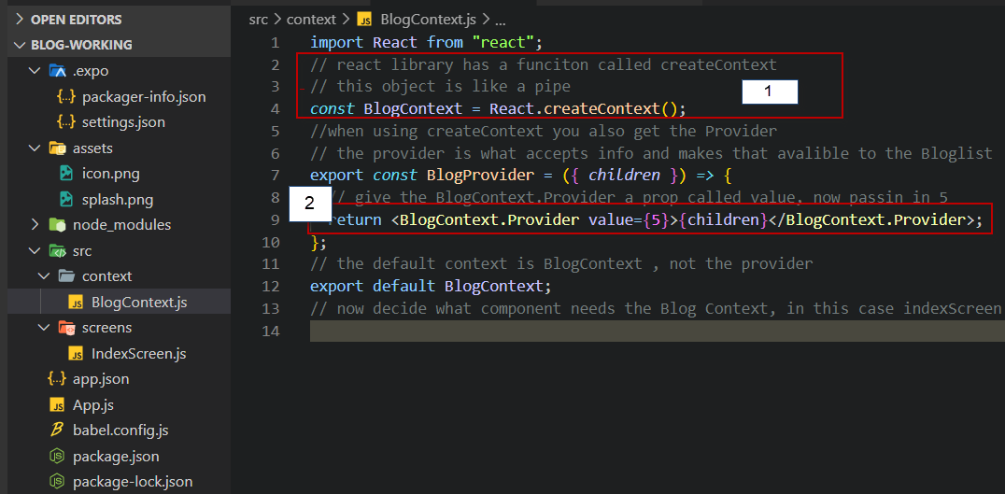

On receiving end

Get value prop

Import useContext and the context object created

Call useContext and put in the context object, that will give the value

